SPIE JOURNALS
Optical Engineering

The flagship monthly journal of SPIE, Optical Engineering (OE) publishes peer-reviewed papers reporting on research and development in all areas of optics, photonics, and imaging science and engineering.
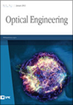

Journal of Biomedical Optics

The Journal of Biomedical Optics (JBO) publishes peer-reviewed papers on the use of modern optical technology for improved health care and research. JBO increased its publication frequency from bimonthly to monthly in 2011.
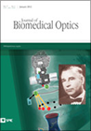

Journal of Electronic Imaging

The Journal of Electronic Imaging (JEI), copublished quarterly with the Society for Imaging Science and Technology, publishes peer-reviewed papers that cover research and applications in all areas of electronic imaging science and technology.
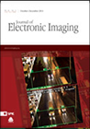

Journal of Micro/Nanolithography, MEMS, and MOEMS

The Journal of Micro/Nanolithography, MEMS, and MOEMS (JM3) (formerly the Journal of Microlithography, Microfabrication, and Microsystems) publishes peer-reviewed papers on the development of lithographic, fabrication, packaging, and integration technologies to address the needs of the electronics, MEMS/MOEMS, and photonics industries.
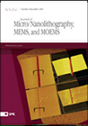

Journal of Applied Remote Sensing

The Journal of Applied Remote Sensing (JARS) is an online-only journal that covers remote sensing research and applications.
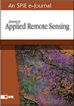

Journal of Nanophotonics

The Journal of Nanophotonics (JNP) is an online-only journal that focuses on the fabrication and application of nanostructures that facilitate the generation, propagation, manipulation, and detection of light from the infrared to the ultraviolet regimes.
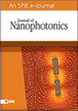

Journal of Photonics for Energy

The Journal of Photonics for Energy (JPE) covers fundamental and applied research areas focused on the applications of photonics for renewable energy harvesting, conversion, storage, distribution, monitoring, consumption, and efficient usage.
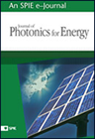

Journal of Medical Imaging

The Journal of Medical Imaging (JMI) covers fundamental and translational research and applications focused on photonics in medical imaging, which continue to yield physical and biomedical advancements in early detection, diagnostics, and therapy of disease as well as in the understanding of normal.

Journal of Astronomical Telescopes, Instruments, and Systems

The Journal of Astronomical Telescopes, Instruments, and Systems (JATIS) covers development, testing, and application of telescopes, instrumentation, techniques, and systems for ground- and space-based astronomy.
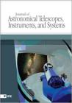

Neurophotonics

Neurophotonics covers advances in optical technology applicable to study of the brain and their impact on basic and clinical neuroscience applications.
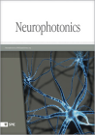

SPIE Reviews
SPIE Reviews is an open-access virtual journal that includes review articles, tutorials, and plenaries covering the state of the art of emerging and rapidly evolving optics and photonics technologies and their applications. The journal features links to selected reviews and tutorials published in SPIE's seven topical journals as well as selected plenary papers from SPIE Proceedings. All articles selected for inclusion in SPIE Reviews are open access and freely available to all.
